Christopher Morcom

CS 487

03 July 2019

**Homework 1**

Answer each of the following with respect to the software engineering process discussed in lecture:

* 1. Describe the purpose of each development phases:
     + Analysis – outlining and understanding the user’s requests to clarify the user needs/wants in the project.
     + Design – A rough architecture and framework that shows a clear, optimized plan for creating the solution. Many people skip this and go straight to the ‘build’ step.
     + Build – The actual engineered vision of the project. If the development phases are not followed correctly, many conflicts can occur at this stage.
     + Verify – Creating test cases and testing the limits of the program so it is ready for release.
     + Release – Outsourcing or distributing your product to consumers. Customer-code checking depends on the contract, where consumers will test the product before public release.
     + Maintenance – Fixing, updating, or improving the product for a variety of reasons that are dependent on the circumstances at the time (ex. patching or adding features).
  2. True or False – Every development effort will have acceptance testing? Explain your answer.

Every development effort will have acceptance testing. This entails the customer “accepting” the product for use which means that all the customer’s requirements have been met and the product works. Declining acceptance testing can be for reasons like not liking certain features or technical errors, where the project will go through the development stages until “acceptance”. Finally, acceptance testing can either be done formally or informally, where the customer has the right to refuse and reject the product in terms of what is outlined in the contract which ensures the user’s right to “acceptance test” a product in some way.

* 1. Analyze the effectiveness of the iterative approach
     + Draw a flowchart with 3 iterations

Start

Analysis

Design

Build

Test

End

Yes

No

Did you ask all questions?

No

Are you prepared for building?

Yes

Did you ask all questions?

No

Is Testing Successful?

Yes

No

* + - Plot the estimated likelihood of “success” (vertical axis) at the end of each iteration (horizontal axis)

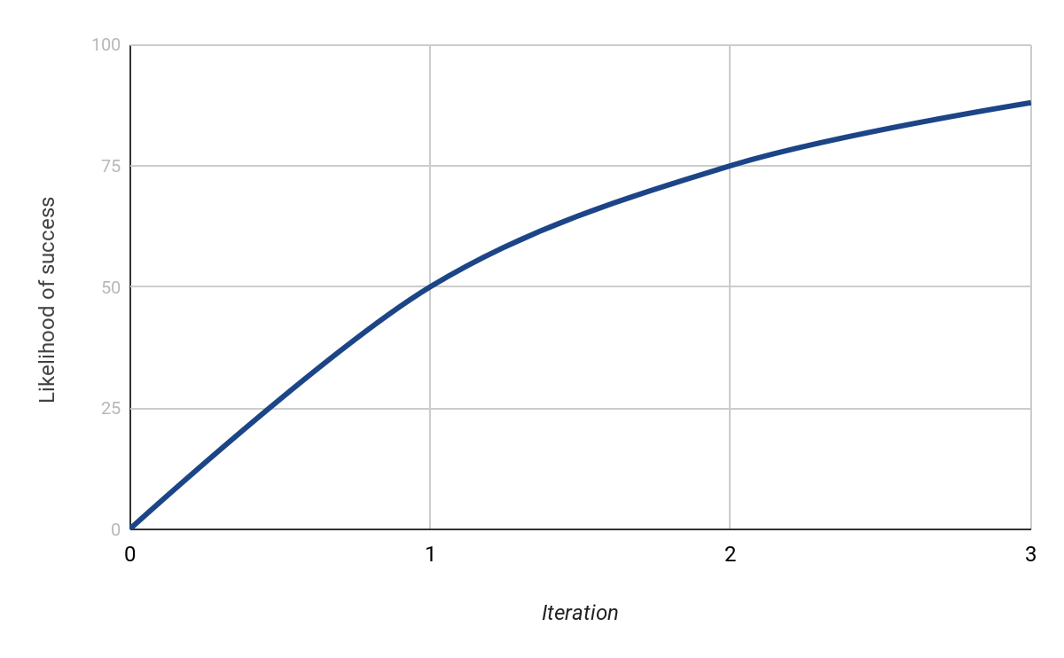

* + - Explain your plot:

1) Why are the likelihoods changing?

Each iteration makes it more likely that you will succeed on a successive iteration If processes are followed.

2) Is it “worth it” to add more iterations?

It is almost a requirement to add multiple iterations. A product may seem 100% or close to it, but during internal/acceptance testing at the customer’s side, they may still decline the product. It is better to have a concrete product rather than leave gaps that may result in a longer development process.

3) How would you prove that it is “worth it”?

The Iterative success ratio scales less per iteration. For instance, 1 iteration gives 50%, 2 gives 75%, 3 gives 87.5%, etc. At 4, we get 93.75%, which is passable during development if close monitoring of progress with the customer is kept throughout the project. This may reduce profits in the short term, but in the long term, it is better than expending on maintenance and update distribution later on, which begets no profits.